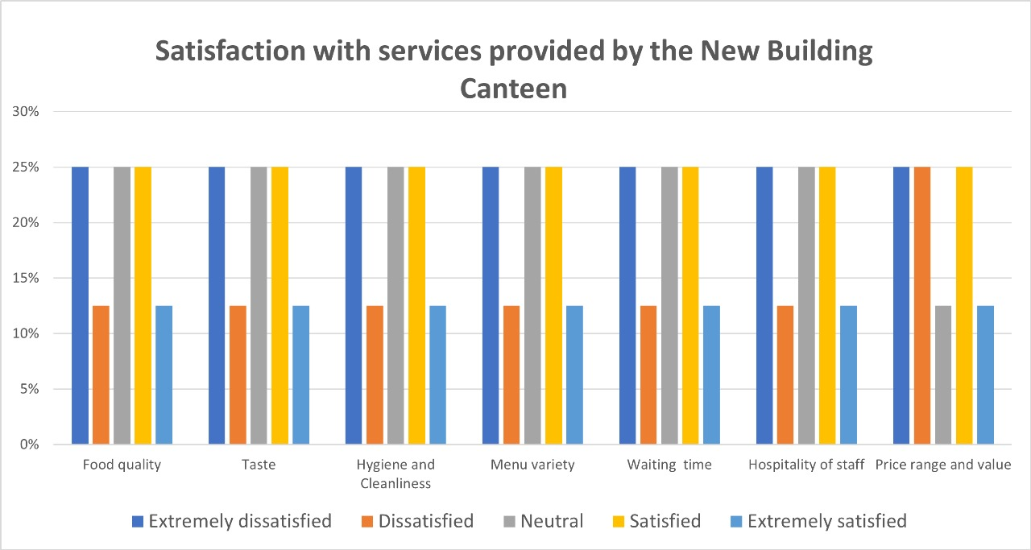

According to the above bar graph, Customers were not happy with the meal quality in the slightest, with 33% expressing serious displeasure and 16% expressing dissatisfaction. This suggests that there is a serious problem with the general quality of the food being provided. Similarly, a significant area of worry was indicated by the high percentage of extreme unhappiness (37%), which was related to flavor. Merely 5% of patrons expressed strong satisfaction with the food's flavor.

Even while just 33% of respondents indicated acute unhappiness with cleanliness and hygiene, this is still a serious worry. Ensuring optimal cleanliness standards is crucial for both client contentment and well-being. Along with other criteria, the data demonstrates a constant trend. Notably, 33% of consumers expressed serious displeasure with the menu variety. This implies that in order to satisfy a wider spectrum of tastes, the canteen may need to expand the variety of items it offers. When compared to other characteristics, waiting time had a comparatively higher satisfaction rate—10% of consumers reported extreme satisfaction.

Nonetheless, there's still opportunity for development, as 33% indicated very high discontent. The data suggests that, in comparison to other variables, there is a comparatively greater degree of pleasure with the staff's hospitality, with 10% expressing extremely high levels of satisfaction. This implies that the employees are typically kind and accommodating. Although a considerable proportion of consumers (33%) reported being extremely dissatisfied with the value and price range, a noteworthy proportion (10%) expressed extreme satisfaction. This suggests that patrons' opinions about the canteen's value and cost are divided

Overall, the data highlights several areas requiring immediate attention, particularly food quality, taste, hygiene, and menu variety. Addressing these concerns could significantly enhance customer satisfaction and drive positive word-of-mouth for the canteen. Additionally, improving waiting times and ensuring consistent hospitality can further enhance the overall dining experience. Lastly, re-evaluating pricing strategies to better align with perceived value could also contribute to overall customer satisfaction and retention.

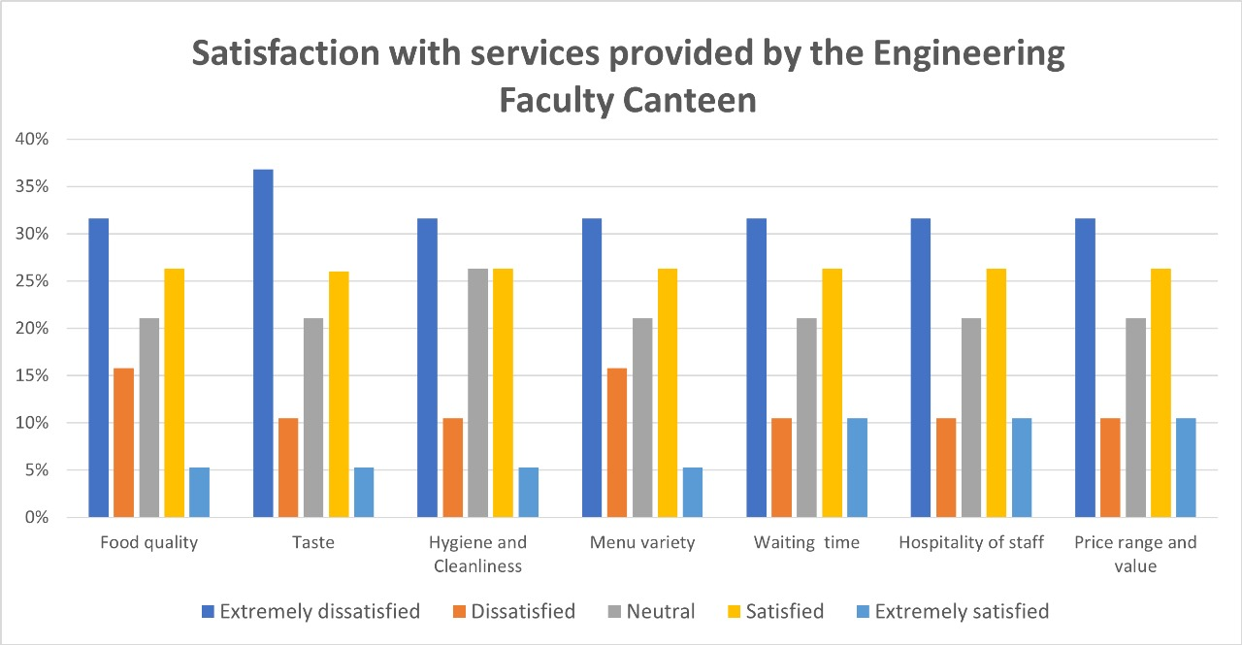

According to the above bar graph a sizable percentage of respondents (49%) say they are either extremely or somewhat dissatisfied with the quality of the cuisine. Merely 31% express satisfaction or very high satisfaction, indicating a significant need for improvement. Concerns about taste also surface, with 48% of respondents expressing moderate to severe displeasure. Comparable to food quality, just 31% of respondents say they are very or very satisfied with flavor. Even while people are more satisfied with cleanliness and hygiene than other factors, 32% of people are still very or extremely dissatisfied. Nonetheless, a sizable portion (31%) express satisfaction or high satisfaction with the standards of cleanliness.

Menu diversity is another area of worry, with 49% reporting unhappiness or great discontent, similar to food quality and taste. Still, a respectable percentage (31%) say they are happy with the range that is provided. With 37% expressing happiness or intense satisfaction, waiting time appears to be one of the more positive components of the canteen experience. Nonetheless, a sizable percentage (44%) continue to express discontent or extremely discontent.

Relatively speaking, staff hospitality does better, with 37% reporting extraordinary or satisfied satisfaction. Still, over half (44%) voice discontent or extremely dissatisfied feelings. Value and price range appear to be other areas of worry as well, as 44% of respondents expressed dissatisfaction or serious discontent. Nonetheless, a sizable percentage (37%) still express satisfaction with the perceived value and cost.

The Engineering Faculty Canteen needs improvement in food quality, taste, menu variety, waiting time, and staff hospitality to enhance student and faculty satisfaction, maintain cleanliness standards, and adjust price ranges for a positive dining experience.